Name: ________________________________________________ Class: _________________________________
U.S. History Term 1 Study Guide ANSWERS
Test Date: ______________
Introduction to U.S. History
- What are some reasons to study history?
- To not repeat the mistakes of the past
- To see how current events are an effect of the past
- To become a better citizen

- Define political and physical map.
- Political map – Shows the boundaries of States and Countries
- Physical map – Shows physical features like mountains and rivers
- Label the following lines on the globe:
- Equator
- Prime meridian
- Arctic & Antarctic Circles
- Tropic of Cancer & Capricorn

- On the globe draw lines of latitude.

- On the globe draw lines of longitude.

- What features are commonly found on a map? Key, legend, scale, compass rose

- Label the 6 regions of the U.S. on the map:

Remember to go over where the states are located and what region they are in.

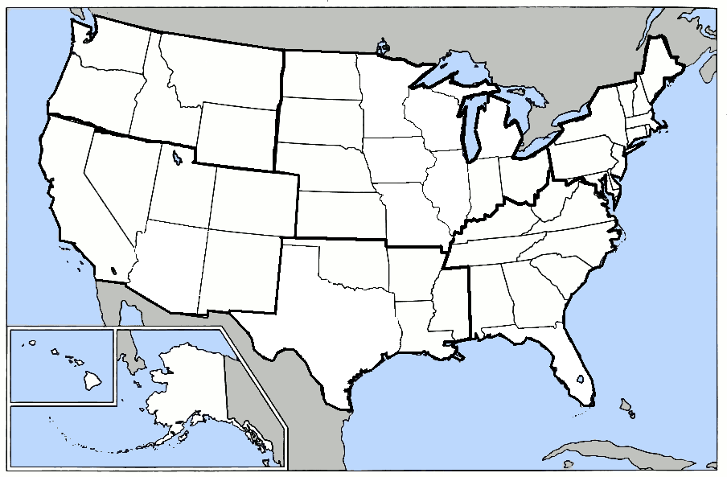

- What is the definition of a primary source? Something made or written by someone who was there at the time.

- Give an example of a primary source: Journal, Letter, diary, uniform of a civil war soldier

- What is the definition of a secondary source? Something made or written by someone who was NOT there at the time.

- Give an example of a secondary source: biography, encyclopedia, movie review, magazine article,

- What is the difference between a fact and an opinion? A fact does not change depending on how someone feels about it.

Native Americans
- The Inca:
Where did they live? Peru
Who was their emperor? Pachacuti
What was their capital city? Cuzco
What things are they most remembered for? Rope with knots to count, rope bridges

- The Mayan:
Where did they live? Yucatan Peninsula, Belize and Guatemala
What was their capital city? Tikal
What things are they most remembered for? Pyramids, calendar,

- The Aztec:
Where did they live? Central Mexico
Who was their emperor? Montezuma
What was their capital city? Tenochtitlan
What things are they most remembered for? Conquered by Cortez, human sacrifice

- Define the following words:
- Theocracy- A government ruled by religious leaders

- Carbon dating- a way for scientists and historians to determine the age of an object

- What determined the culture of American Indians? (Their homes, what they wore, what they ate etc)
The geography of the land they lived on and what resources it provided… determined the culture of the tribe.

- What were the following Indian tribes known for?

- Anasazi- Cliff Dwellings
- Inuit- Cold Artic
- Iroquois confederacy – Indian Confederacy that included the Onondaga, Mohawk, Oneida, Cayuga, and the Seneca that was formed to defend against the Huron and the French?

- What were some of the reasons for the destruction of Native American cultures? Disease, spread of Christianity and conquest of tribal lands

Explorers
- What two countries led the way in early exploration and had to have the pope divide their claims by drawing the line of demarcation? Portugal and Spain

- Why was Prince Henry the Navigator so important to exploration? Where was he from? He started a school for exploration and he was from Portugal.

- Name some of the reasons that Europeans wanted to expand their empire. (hint: the 3 G’s) Gold, God, Glory

- Name some of the items that Europeans were looking for in their voyages? Perfume, Spices, Silk, cloth, precious stones

- Who was Bartolome de las Casas and why is he important? Catholic priest condemned the unethical treatment of Native Americans and enabled Spain to enact laws protecting them.

- What part of the United States did the following countries explore?
- France- WEST of the Appalachian Mountains, the Ohio River Valley, and the Mississippi River?
- Spain- Florida and western portion of America?
- England- eastern seaboard of what became the United States?

- Explain some of the reasons why Columbus sailed west instead of east to reach the Indies? To avoid piracy in the Mediterranean and cut out the middle man in trade

- Why did Columbus sail for Spain if he was Italian? The Spanish gave him the money to finance his expedition

- What did Columbus name the island he landed on? Hispaniola

- What is this island known as today? Haiti and the Dominican Republic

- Where did Columbus believe he had landed? The Indies

- What did Marco Polo do when he returned from his years in the Orient? wrote a book of his experiences in China over 17 years that inspired other countries to find a trade route to the Indies?

- What did Magellan do? circumnavigate the globe

- Why is America named after Amerigo Vespucci? HE realized that America was not the Indies.

- Where was de Soto looking for gold? The southern portion of America including the Mississippi River Valley. He died and was buried in the Mississippi River to hide his body from the Native Americans.

- Who did Cortez conquer? He conquered the Aztec empire, killing off thousands of Native Americans

- What were some contributing factors that led to the destruction of Native American culture by Europeans? Disease, Spread of Christianity, conquest of tribal lands

- What did Europeans gain in the Columbian Exchange? Chocolate, Llamas, Chili peppers, buffalo, Raccoons

- What did Americans gain in the Columbian Exchange? New Technology, New Languages, new foods and animals

- Why do we speak English, French, Spanish and Portuguese in America today? Because those countries settled

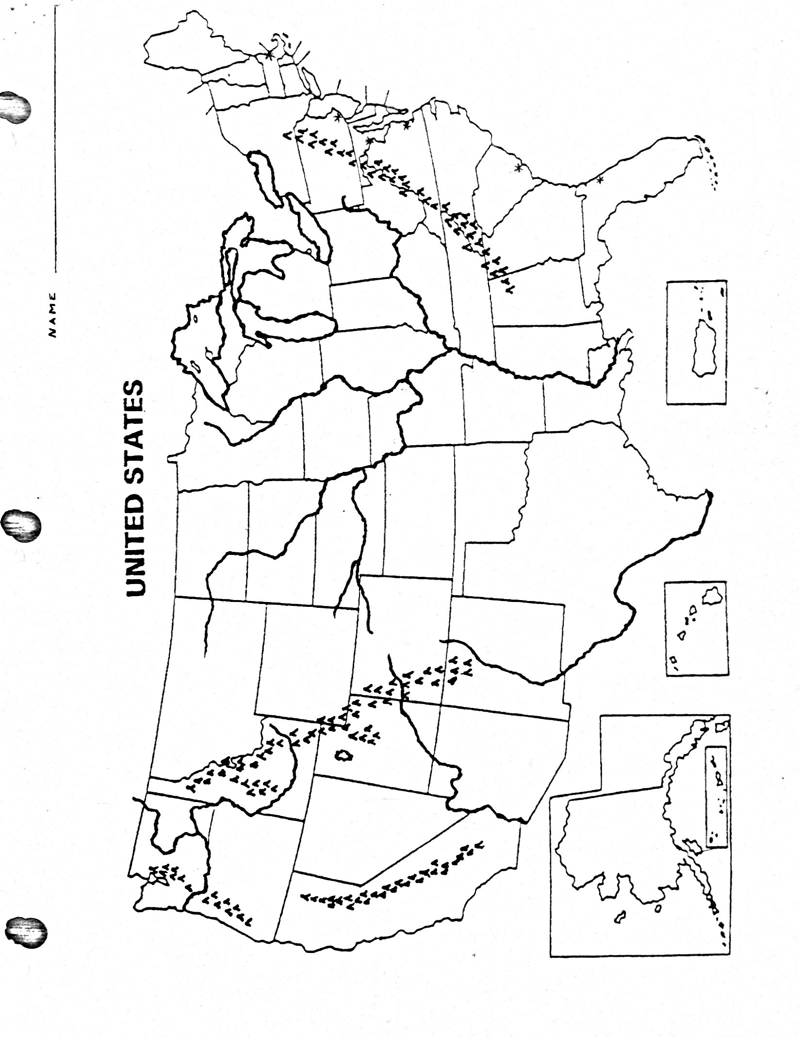
- Label:

- Mississippi River
- Snake River
- Platte River
- Rio Grande River
- Missouri River
- Ohio River
- Colorado River
- Columbia River
- Great Basin
- Great Plains
- Coastal Plains
- Appalachian Mtns
- Sierra Nevada Mtns
- Rocky Mtns
- Cascade Mtns

